
Title:
Car Price Predictor

Submitted By:
- Haleema Azeem
- Abdullah Butt
- Mubeen Saleem
4. Jahanzeib Khan
Subject: Artifcial Intelligence

Teacher Name: Sir Hameedoon
Semester: 5th

Final Report

Project Description:

This project is called Car Price Predictor Using Machine Learning.
The main purpose of this project is to predict the price of a used car by using machine learning techniques.

In this system, different car details such as brand, model, year, mileage, engine size, fuel type, and transmission are used. These details are given to a machine learning model, and the model predicts an estimated price of the car.

The project helps people who want to buy or sell used cars. Buyers can check whether the price is fair, and sellers can decide a reasonable selling price. The model is trained on real car data so that predictions are more accurate and reliable.

Flow Diagram:

┌──────────────────┐
│ Start │
└────────┬─────────┘
│
▼
┌────────────────────────────┐
│ Jupyter Notebook (.ipynb) │
│ Opened │
└────────┬───────────────────┘
│
▼
┌────────────────────────────┐
│ Load Dataset (CSV file) │
│ Car details & prices │
└────────┬───────────────────┘
│
▼
┌────────────────────────────┐
│ Data Preprocessing │
│ - Handle missing values │
│ - Encode categorical data │
│ - Feature selection │
└────────┬───────────────────┘
│
▼
┌────────────────────────────┐
│ Train ML Model │
│ (Linear Regression / │
│ Random Forest etc.) │
└────────┬───────────────────┘
│
▼
┌────────────────────────────┐
│ Evaluate Model Accuracy │
│ (R², MAE, RMSE) │
└────────┬───────────────────┘
│
▼
┌────────────────────────────┐
│ Save Trained Model │
│ (model.pkl / joblib file) │
└────────┬───────────────────┘
│
▼
┌────────────────────────────┐
│ Backend (Flask / FastAPI) │
│ Loads saved ML model │
└────────┬───────────────────┘
│
▼
┌────────────────────────────┐
│ User opens Web Page │
│ (index.html) │
└────────┬───────────────────┘
│
▼
┌────────────────────────────┐
│ User enters car details │
│ (brand, model, year, etc.) │
└────────┬───────────────────┘
│
▼
┌────────────────────────────┐
│ Click "Predict Price" │
│ Button │
└────────┬───────────────────┘
│
▼
┌────────────────────────────┐
│ JavaScript sends POST │
│ request to /predict API │
└────────┬───────────────────┘
│
▼
┌────────────────────────────┐
│ Backend uses trained │
│ ML model to predict price │
└────────┬───────────────────┘
│
▼
┌────────────────────────────┐
│ Predicted price returned │
│ as JSON response │
└────────┬───────────────────┘
│
▼
┌────────────────────────────┐
│ Predicted price displayed │
│ on web page (₹) │
└────────┬───────────────────┘
│
▼
┌──────────────────┐
│ End │
└──────────────────┘

Project Code:

Inputs :

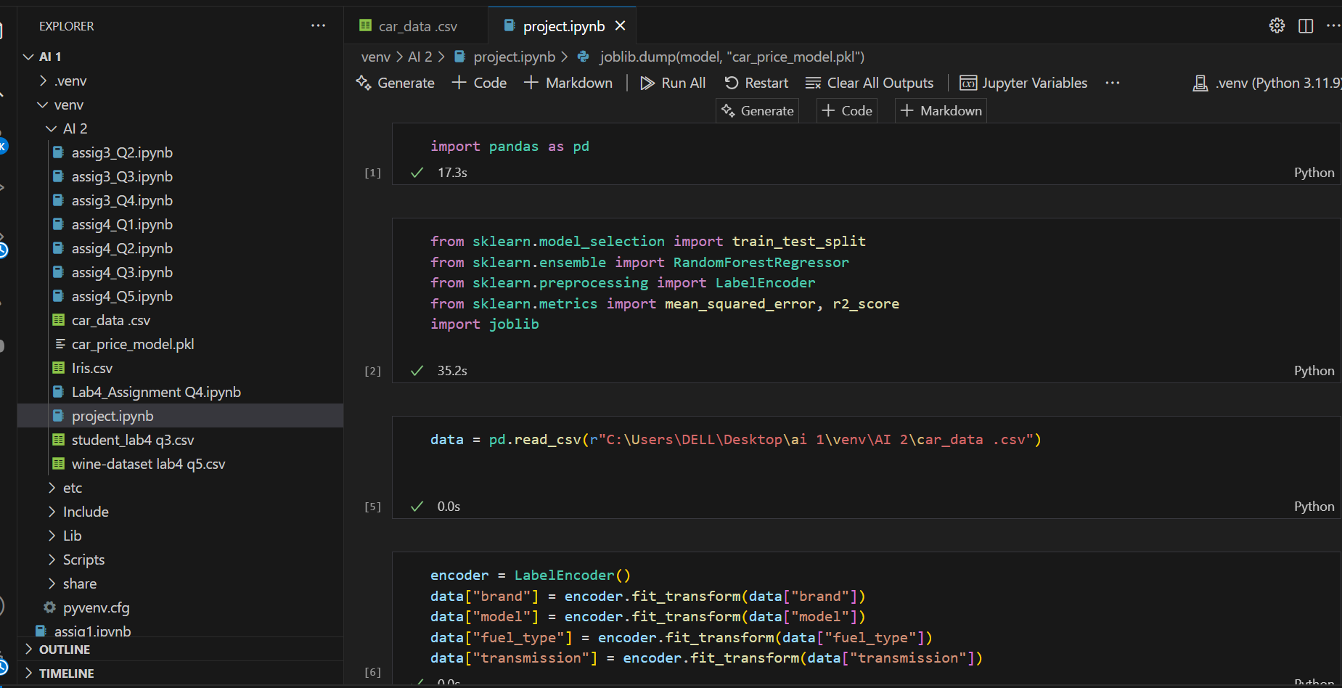

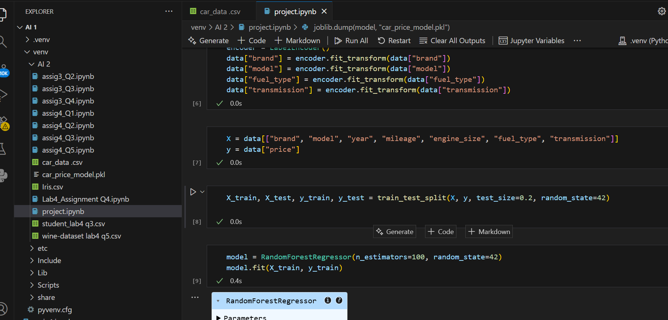

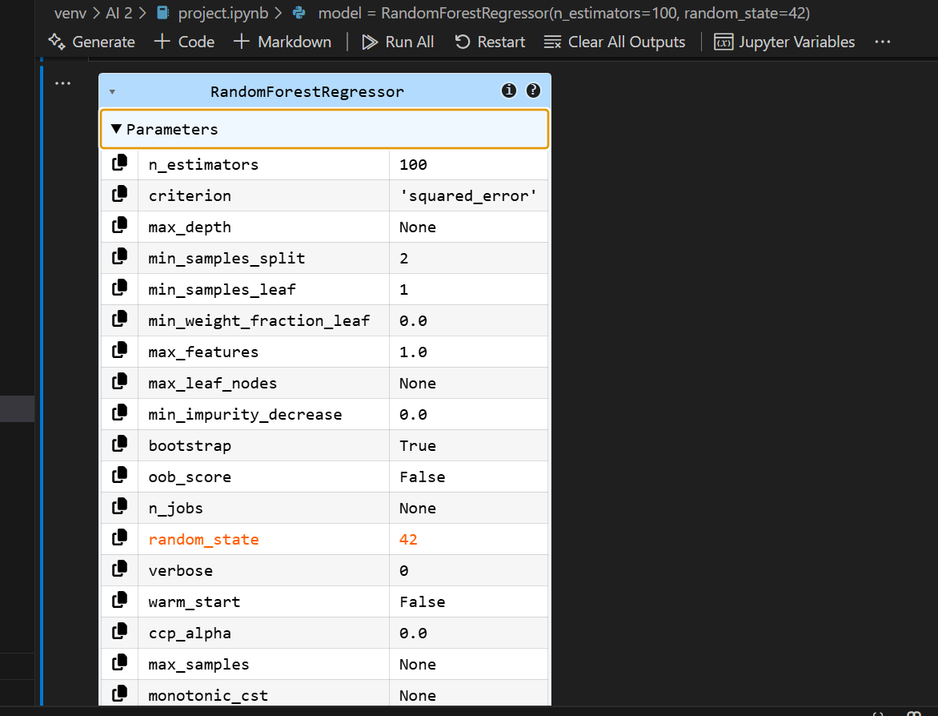

Outputs:

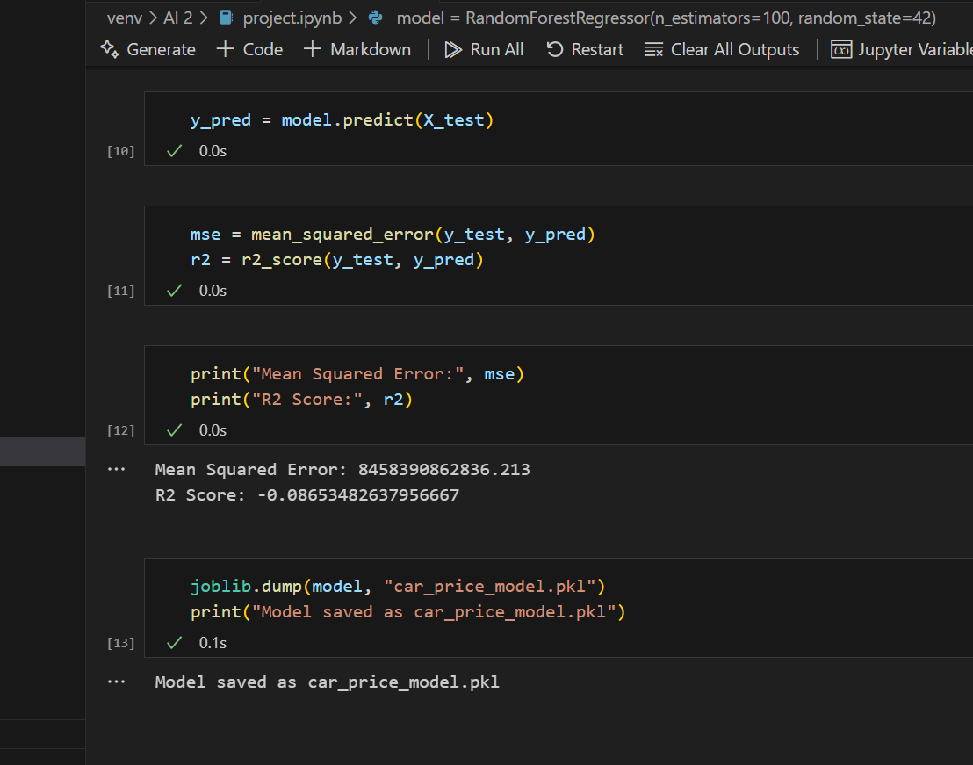

Scope of the Project:

- This project can be used in online car selling platforms to show estimated car prices.
- It helps buyers to avoid overpaying for used cars.
- It helps sellers to set a fair and competitive price.
- The system can be improved by adding more features like car condition, accident history, or location.
- In the future, it can be converted into a web or mobile application for public use.
- The model can be retrained with new data to improve accuracy over time.

LINK

https://github.com/haleema123-web/AI-Project-and-Lab-Manual

